**LAB - 4**

# Lasso And Ridge Regression.

## **Ridge Regression:**

Ridge regression is a technique used to analyze multi-linear regression (multicollinear), also known as L2 regularization. It is Applied when predicted values are greater than the observed values.

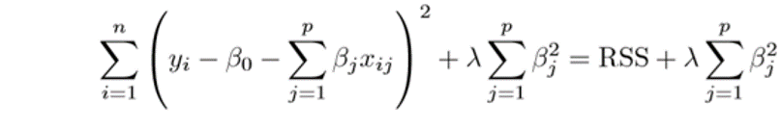

Above equation represents the formula for Ridge Regression! where,

Lambda (λ) in the equation is tuning parameter which is selected using cross-validation technique which makes the fit small by making squares small (β2) by adding shrinkage factor.

**The shrinkage factor** is lambda times the sum of squares of regression coefficients (The last element in the above equation).

## **Lasso Regression:**

Lasso stands for – Least Absolute Shrinkage and Selection Operator. It is a technique where data points are shrunk towards a central point, like the mean. Lasso is also known as L1 regularization.

It is applied when the model is overfitted or facing computational challenges.

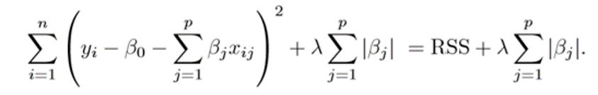

The above equation represents the formula for Lasso Regression! where, Lambda (λ) is a tuning parameter selected using the before Cross-validation technique.

Unlike Ridge Regression, Lasso uses |β| to penalize the high coefficients.

**The shrinkage factor** is lambda times the sum of Regression coefficients (The last factor in the above equation).

**Dataset**-

Dataset from an Ad Agency! that advertised their Ad through different forums such as TV, Radio, and Newspapers and recorded their sales against it!

Complete Implementation -

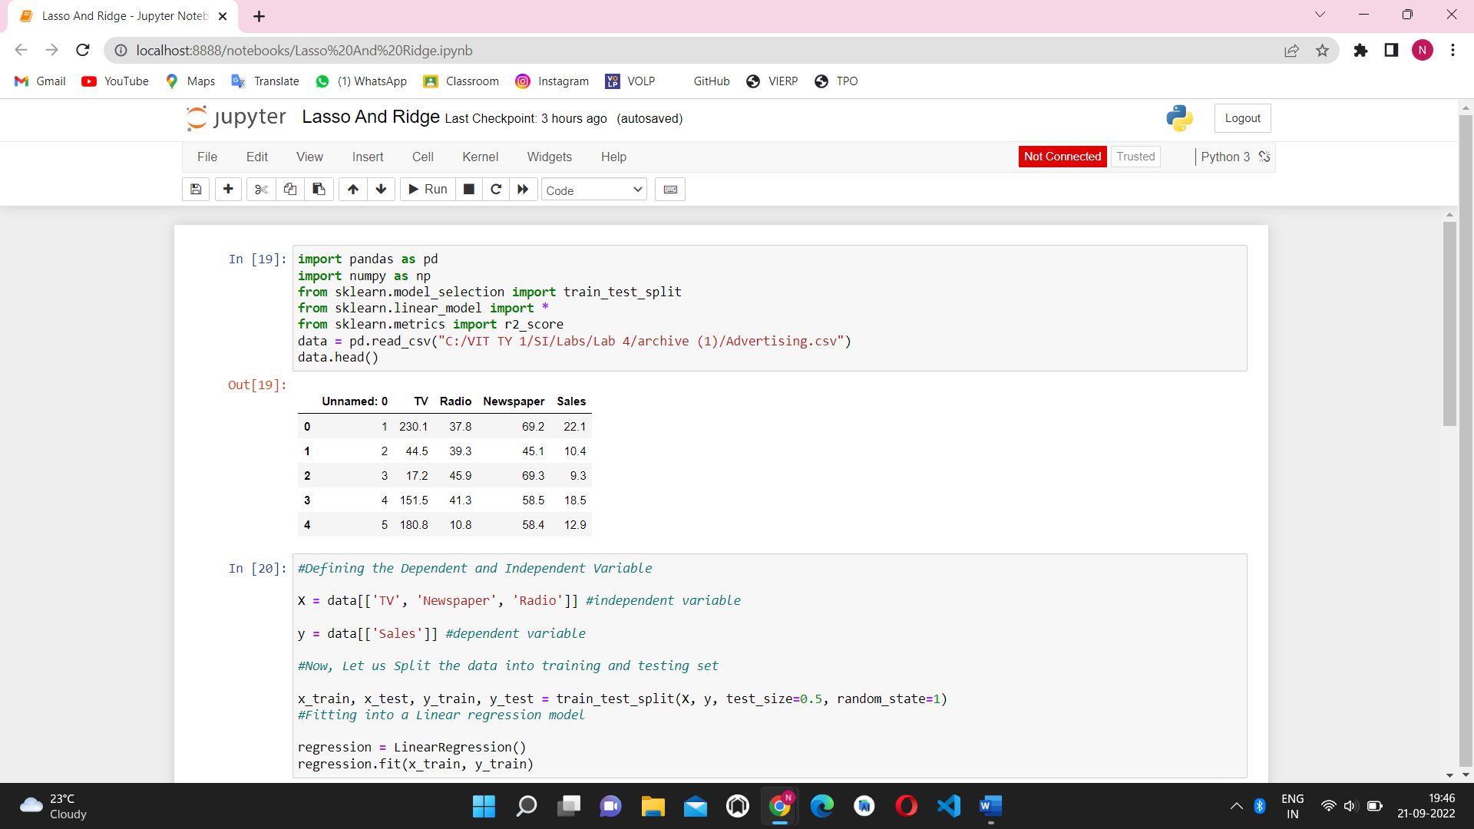



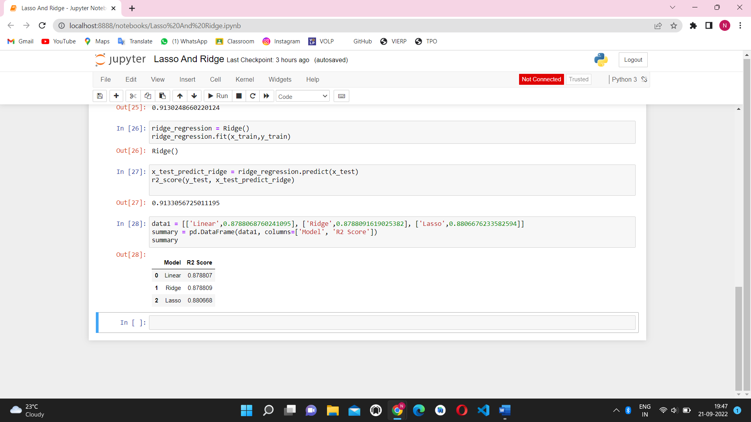

**Conclusion** – We implemented Ridge Regression vs Lasso Regression to find there r2 score and example how these models improve accuracy.As a result, we gained a more profound knowledge of lasso and ridge regression through the use of an example dataset and came to know that lasso regression score is more than the linear and ridge regression due to square function.